**LAKSHMI PRIYA 231901025**

**EXERCISE 1A WINDOWS FUNDAMENTALS 1**

**AIM**:

To understand the fundamentals of the Windows operating system, including the Windows desktop, NTFS file system, User Account Control (UAC), Control Panel, and other essential features.

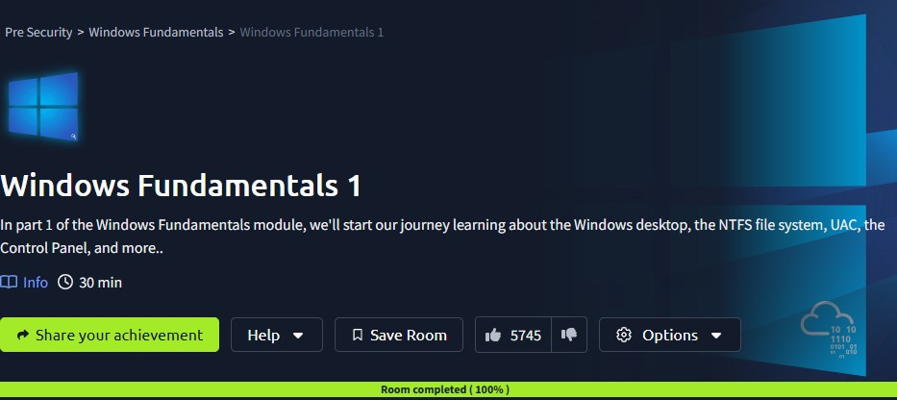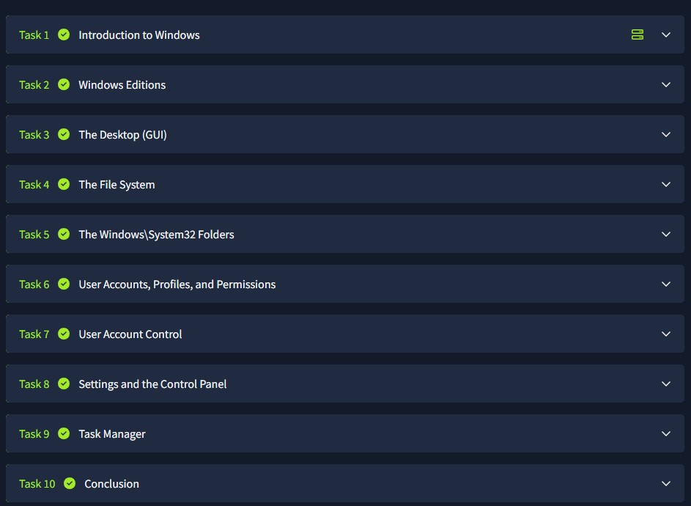

**RESULT**:

Successfully gained an understanding of the Windows desktop environment, NTFS file system, User Account Control (UAC), Control Panel, and other fundamental Windows features.